

American International University-Bangladesh (AIUB)
Department of Computer Science
Faculty of Science & Technology (FST)
A Specialized E-Commerce Platform for Computer Accessories(E-Connect)

A Software Requirement Engineering Project
Submitted By

Semester: Spring_24_25 |  | Section: | Group Number:
SN | Student Name | Student ID | Contribution in %  (100%) | Individual  Marks
1 | S. M. MUJAHID SOUROV | 22-49679-3 | 33.33%
2 | MD. THAMEDUL ISLAM SHADIN | 22-49676-3 | 33.33%
3 | SHAHRIYER ISLAM | 22-49675-3 | 33.33%

The project will be Evaluated for the following Course Outcomes

EVALUATION CRITERIA | Total Marks (50)
EVALUATION CRITERIA | 40
Introduction [Section 1.1-1.4], Format, Submission, Defense | [10 Marks]
System Overall Description & Functional Requirements | [10 Marks]
System Quality Attributes and Project Requirements | [10 Marks]
UML and E-R Diagram with Data Dictionary | [10 Marks]
UI/UX Prototyping | [10 Marks]

Software Requirements Specification

For

A Specialized E-Commerce Platform for Computer Accessories (E-Connect)

Version 1.0 approved
Date: 15.01.2026

Revision History
S. M. MUJAHID SOUROV | Jan 02, 2026 | Initial Draft Creation and UI/UX | 0.1
MD. THAMEDUL ISLAM SHADIN | Jan 06, 2026 | Added System Features and Functional Requirements, Gantt chart | 0.5
SHAHRIYER ISLAM | Jan 09, 2026 | Updated Use Case Diagrams, Outline,Timeline | 0.8
S. M. MUJAHID SOUROV | Jan 11, 2026 | Final Review and Approval for Submission | 1.0

INDEX

Revision History 2
1. Introduction 4
2. System Requirements 5
3. UML Design and Interface Requirements 10
4. Social Impact 17
5. Development Plan with Project Schedule 18
6. Project schedule using Project Management Tool: 21
7. Development Plan with Project Schedule 22
8. Marketing Plan 25
9. Cost and Profit Analysis 28
10. References 31

Introduction

Purpose
The purpose of this Software Requirements Specification (SRS) document is to clearly define and describe the software requirements for the project titled “A Specialized E-Commerce Platform for Computer Accessories.” This document serves as a formal agreement between stakeholders and the development team regarding what the system is expected to do and how it should perform.
The SRS includes both functional requirements, which describe the services and features the system will provide, and non-functional requirements, which describe the quality attributes such as performance, security, usability, and reliability. By documenting these requirements in detail, this document helps reduce misunderstandings, prevents scope changes, and ensures consistency throughout the development process.
This document is intended for system developers, project managers, testers, designers, and stakeholders who are involved in the planning, design, implementation, and evaluation of the system. It provides a common reference point that supports system development, testing, maintenance, and future enhancements.
Overall, the main goal of this SRS is to ensure that the proposed e-commerce platform is developed in a structured, efficient, and user-focused manner while meeting business needs and customer expectations.

Background To the Problem
In the modern digital era, computer accessories are very important for daily activities such as studying, office work, and online communication. However, many people face difficulties when trying to buy good-quality accessories at reasonable prices. Physical shops usually have limited product options, and many online platforms do not always ensure product quality, fast delivery, or proper customer service.
The main problem is that there is no specialized and trustworthy online platform that focuses only on computer accessories. As the demand for these products continues to grow, this lack of reliable access affects users’ productivity and makes their technological tasks more difficult.

Solution To the Problem
To solve this problem, a web-based online shop for computer accessories will be developed. This platform will offer a wide collection of quality products with clear pricing and reliable delivery services so that customers can shop with confidence. The system is designed to reduce the gap between customer demand and product availability by making the buying process simple and trustworthy.
The proposed software will work as a specialized e-commerce platform focused only on computer accessories. Its main purposes are:
Benefits: Easy online purchasing, accurate product information, secure payment options, and fast delivery service.
Objectives: To make computer accessories easily available to customers from different locations.
Goals: To build a system that is simple to use, flexible for future growth, and safe for users.
Many existing e-commerce platforms do not properly support technology-related products. They often provide limited technical details, weak delivery services, and poor customer support. By solving these problems, the proposed system aims to improve customer satisfaction and fulfill the unmet needs of the market.

System Requirements

System Features

User Account Management Functional Requirements:

User registration with email, phone number, and social media integration.

Login and logout functionality.

Password reset and account recovery.

User profile management (update personal details, preferences).

- Quality Attributes:

Usability: Simple and intuitive user interface for account setup.

Security: Strong password enforcement and encrypted data storage.

Scalability: Support for many concurrent users.

Product Browsing and Search Functional Requirements:

Categorized product listing (keyboards, mice, monitors, etc.).

Search functionality with filters (price, brand, rating, compatibility).

Detailed product pages with images, specifications, reviews, and ratings.
- Quality Attributes:

Performance: Fast search and filter response times.

Accessibility: Support for mobile devices and screen readers.

Relevance: Accurate search results using advanced algorithms.

Shopping Cart and Wishlist Functional Requirements:

Add, remove, and update items in the shopping cart.

Save products to a Wish list for future purchases.

Calculate total price, including taxes and discounts

Quality Attributes:

Reliability: Ensure cart and Wishlist are persistent across sessions.

Responsiveness: Real-time updates for cart modifications.

Consistency: Ensure accurate pricing and stock availability.

Checkout and Payment Functional Requirements:

Secure checkout process.

Integration with multiple payment gateways (credit/debit cards, PayPal, mobile wallets).

Invoice generation and order confirmation email.
- Quality Attributes:

Security: End-to-end encryption for payment data.

Availability: Minimal downtime for payment services.

Compliance: Adherence to PCI-DSS standards.

Inventory and Order Management Functional Requirements:

Real-time inventory updates.

Admin panel for adding, editing, or removing products.

Order tracking and status updates for customers.
- Quality Attributes:

Scalability: Handle inventory changes for a growing catalog.

Accuracy: Prevent overselling or understocking.

Maintainability: Easy-to-use admin interface for managing products.

Marketing and Promotions Functional Requirements:

Display banners and promotions on the homepage.

Discount codes and seasonal offers integration.

Email campaigns for personalized offers.
- Quality Attributes:

Effectiveness: Targeted and relevant promotions.

Scalability: Handle increased traffic during promotions.

Customizability: Flexible promotional settings.

Analytics and Reporting Functional Requirements:

Track user behavior, sales trends, and website traffic.

Generate detailed reports for sales, inventory, and user engagement.

Insights for marketing and operational decision-making.
- Quality Attributes:

Accuracy: Ensure data integrity in reports.

Efficiency: Generate reports in real-time.

Security: Protect sensitive business data.

Mobile Application Support Functional Requirements:

Responsive design for mobile web users.

Native app support for iOS and Android.

Push notifications for deals, updates, and order status.
- Quality Attributes:

Portability: Consistent experience across devices.

Performance: Optimize app for low-bandwidth environments.

User Experience: Intuitive navigation and touch-friendly UI.

Customer Support Functional Requirements:

Chatbot and live chat for quick queries.

Ticketing system for issue resolution.
- Quality Attributes:

Availability: 24/7 support system.

Responsiveness: Quick resolution times.

Personalization: Context-aware support for returning customers.

Non-Functional/Quality Requirements

QA1: Usability
A normal user shall be able to complete product search and place an order within an average of five minutes and a maximum of eight minutes without external help.
Priority Level: Medium
Precondition: User is logged into the system.
QA2: Performance
The system shall load product listings and search results within three seconds under normal network conditions.
Priority Level: High
Precondition: User has active internet connection.
QA3: Security
All user passwords and payment information shall be stored and transmitted using encrypted methods.
Priority Level: High
Precondition: User performs login or payment operation.
QA4: Reliability
The system shall remain operational at least 99% of the time excluding scheduled maintenance.
Priority Level: Medium
Precondition: Server is active
QA5: Scalability
The system shall support at least 10,000 concurrent users without significant performance loss.
Priority Level: Medium
Precondition: System is deployed on cloud infrastructure
QA6: Availability
The system shall be accessible 24 hours a day except during planned maintenance periods.
Priority Level: Medium
Precondition: Hosting server is online
QA7: Maintainability
System updates and bug fixes shall be applied without affecting existing user data.
Priority Level: Low
Precondition: Admin access is available
QA8: Compatibility
The system shall run properly on major web browsers and mobile devices.
Priority Level: Medium
Precondition: User uses supported browser or device.

UML Design and Interface Requirements

UML Diagrams

Use Case Diagram:
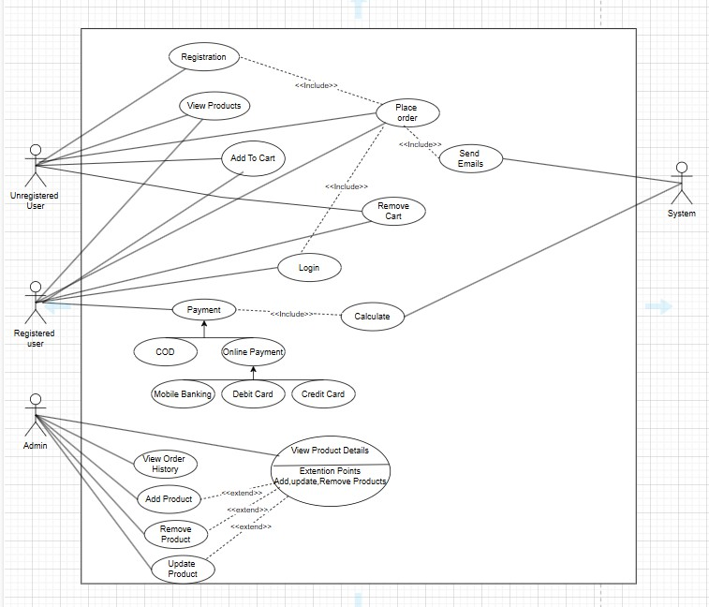

E-R Diagram:
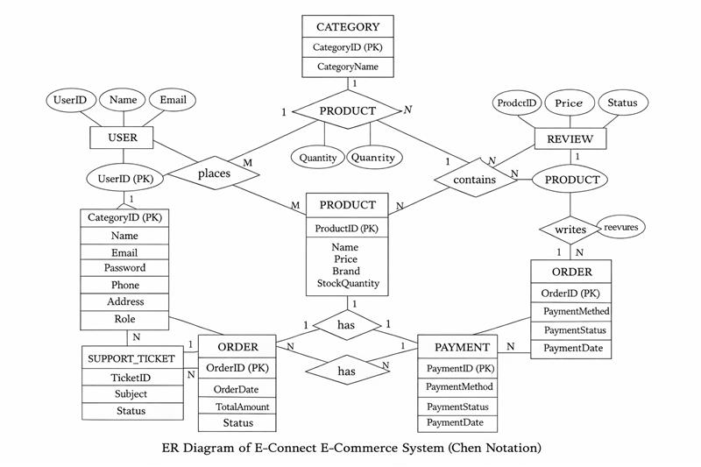
3.2 Class Diagram:

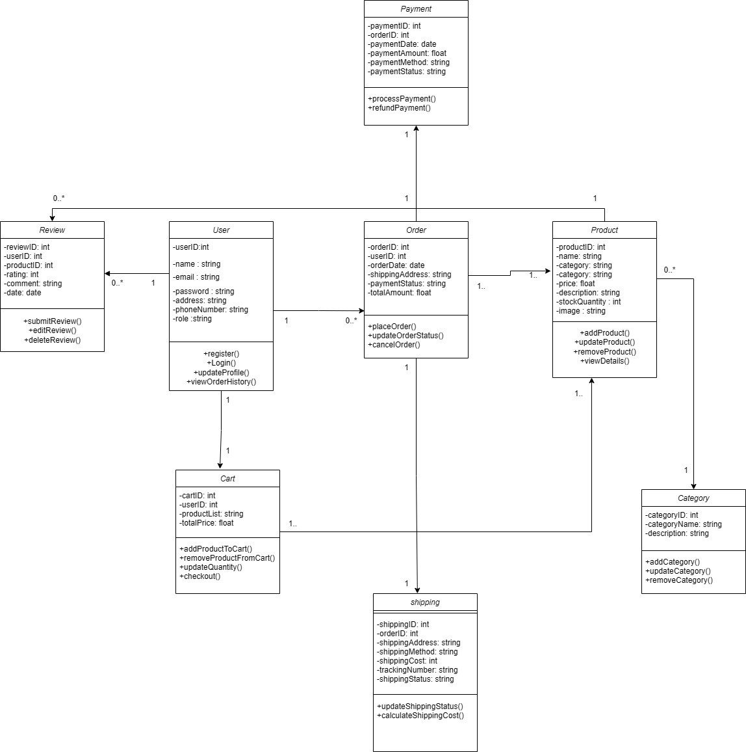

3.3 Activity Diagram:
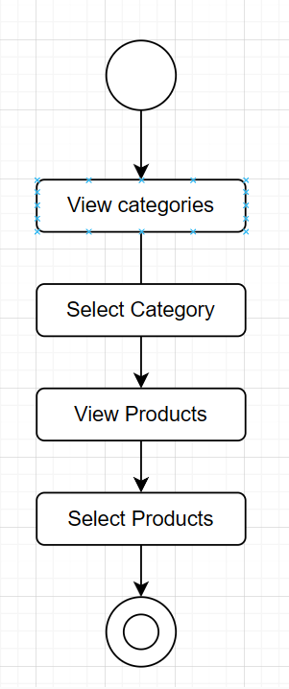
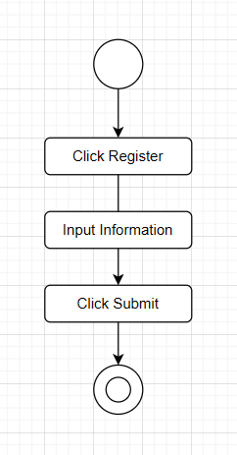
Registration Activity diagram: View category diagram:

Add to Cart activity diagram: Remove Cart activity diagram:
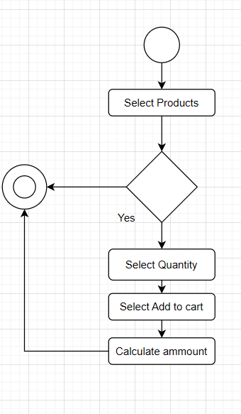
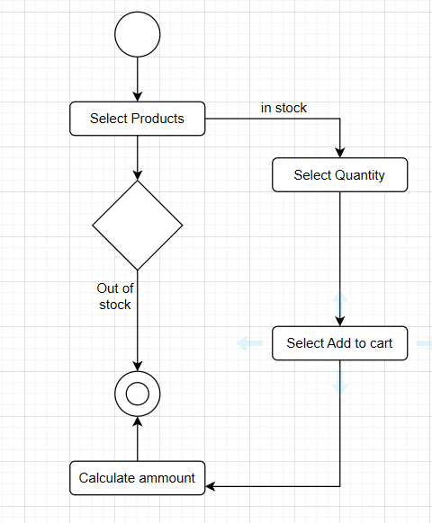

Place Order activity diagram: Login activity diagram:

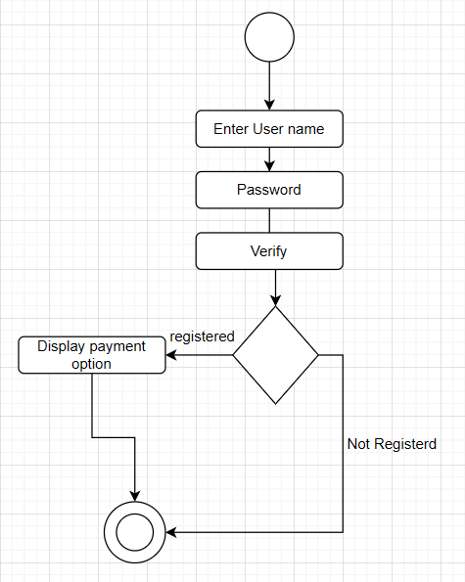
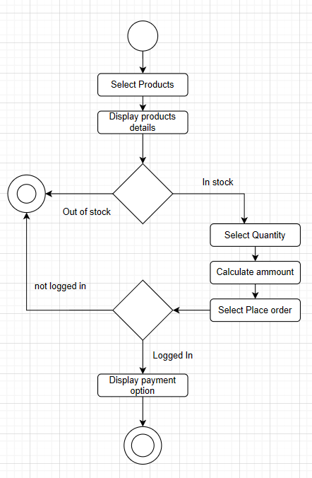

Payment activity diagram: View Order History activity diagram:
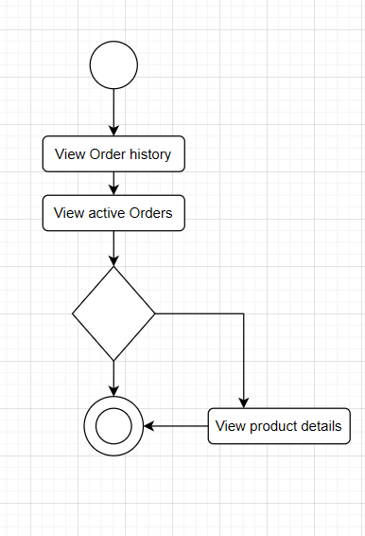
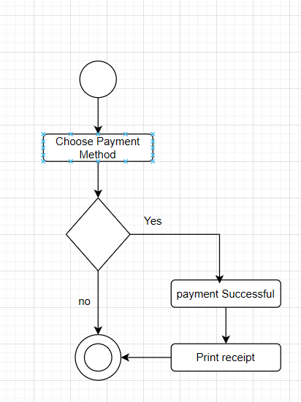

Data Dictionary
Entity | Attribute | Type/Size | Validation | Key
User | UserID | Number (10) | Auto-generated, Unique | Primary
User | Email | Text (100) | Must contain "@" and "."
User | Password | Text (256) | Min 8 chars, Encrypted
User | Phone | Text (15) | Numeric characters only
Product | ProductID | Number (10) | Auto-generated, Unique | Primary
Product | Name | Text (100) | Required
Product | Category | Text (50) | From predefined list
Product | Price | Currency | Must be > 0
Order | OrderID | Number (10) | Auto-generated, Unique | Primary
Order | UserID | Number (10) | Must exist in User table | Foreign
Order | OrderDate | Date | Valid Date Format

UI/UX Design Specification
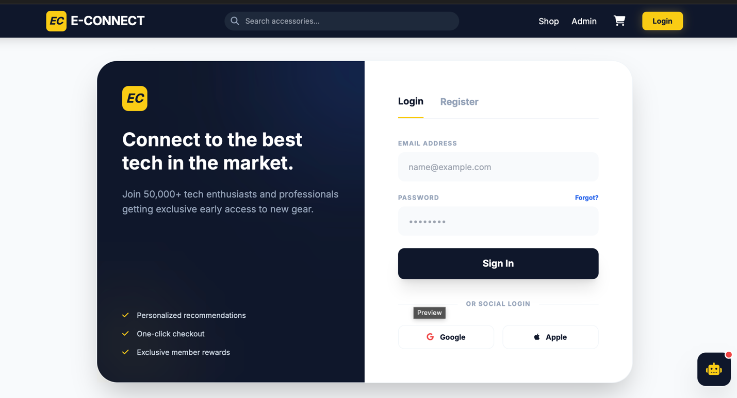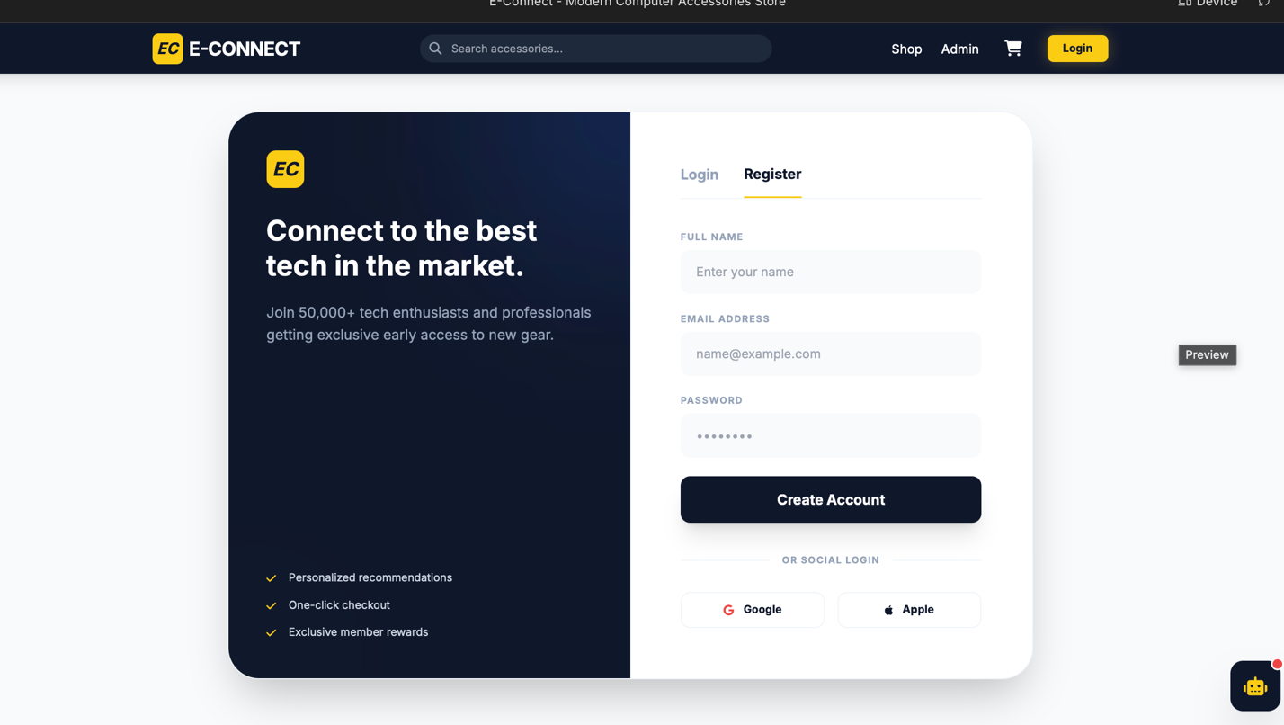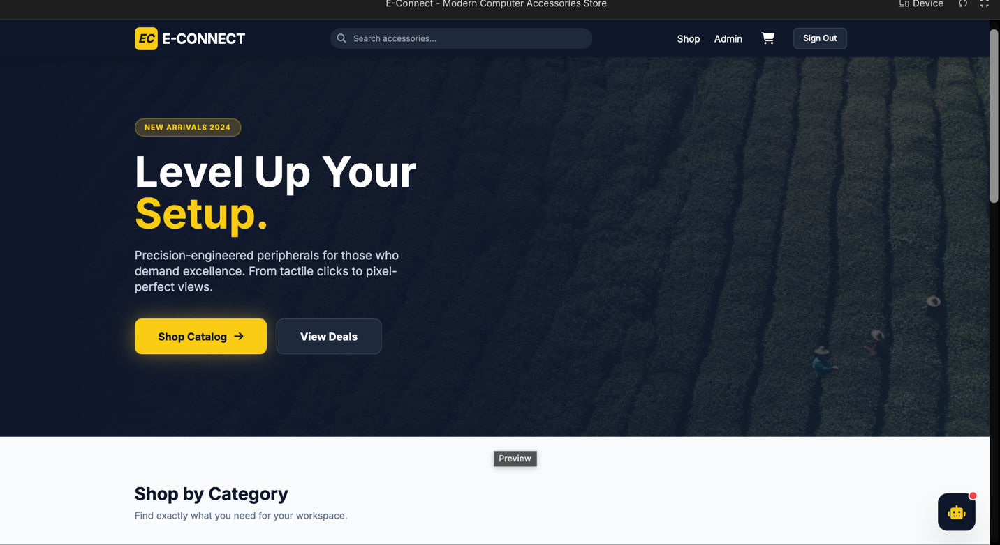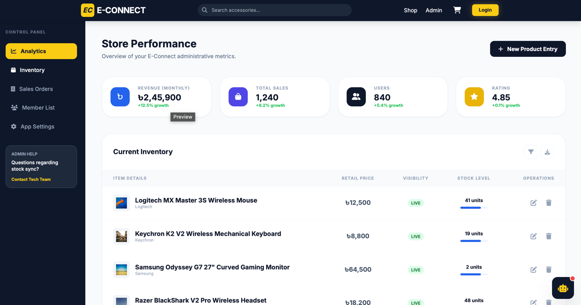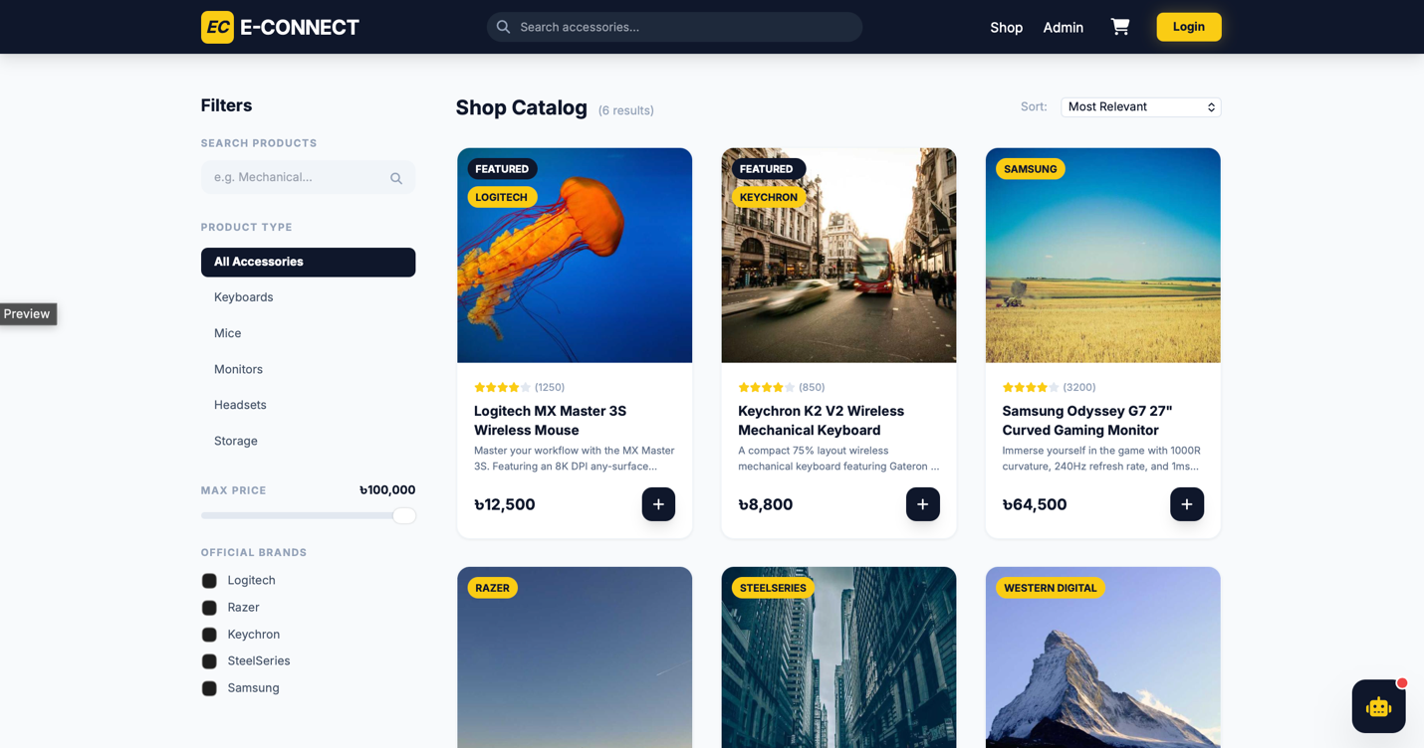

Social Impact
Our online-based computer accessories shop will bring several significant social benefits:
- Improved Accessibility to Technology
  - Customization: Customers, including those in underserved areas, can easily access tailored computer accessories, bridging the technology gap.
  - Affordability: With promotions and competitive pricing, people can upgrade their systems at a lower cost.
- Support for Digital Literacy
  - Offering affordable and accessible computer parts encourages more people to build their computers, fostering technical skills and boosting digital literacy.
- Promoting Local Economy
  - Partnerships with local suppliers and service providers will boost local economies and create job opportunities.
- Convenience for Disabled and Elderly Individuals
  - Our accessible website and mobile app provide an inclusive shopping experience, enabling people with disabilities or limited mobility to shop conveniently from home.
- Environmental Impact
  - The platform encourages sustainable practices through product recycling options and by promoting energy-efficient accessories.
- Enhanced Education and Work-from-Home Opportunities
  - With reliable, affordable computer setups, students and professionals can seamlessly access remote education and work opportunities, contributing to social progress.

Development Plan with Project Schedule

Planning Phase
  - Objective: Define the project's scope, identify stakeholders, estimate costs, and outline the schedule.

Key Activities:
    - Conduct market research to identify competitors and user needs.
    - Define features like product customization, user account management, and secure payments.
    - Prepare a feasibility report and business case.
    - Assign roles to team members and finalize the project plan.

Deliverables:
    - Project charter.
    - High-level timeline and budget.
    - Risk assessment report.

Requirements Analysis Phase
  - Objective: Gather and document the functional and non-functional requirements.

Key Activities:
    - Collect requirements from stakeholders (e.g., admins, customers).
    - Document user stories for all features: account management, product browsing, and checkout.
    - Define technical requirements for security, scalability, and integration with payment gateways.
    - Develop a Software Requirements Specification (SRS).

Deliverables:
    - SRS document.
    - Use case diagrams and workflows.
    - Feature prioritization list.

Design Phase
Objective: Create the blueprint for the system architecture and user interface.

Key Activities:
    - Design the database schema for inventory, orders, and user profiles.
    - Develop wireframes and prototypes for web and mobile interfaces.
    - Plan the API architecture for backend communication.
    - Identify and finalize technologies (e.g., React for frontend, Node.js for backend).

Deliverables:
    - Database schema.
    - System architecture diagrams.
    - UI/UX prototypes.

- Implementation Phase
  - Objective: Build the system modules and integrate them into a working platform.

  - Key Activities:
    - Develop core modules:
      - User Account Management: Registration, login, password recovery.
      - Product Browsing and Search: Filtered search, categorized listings.
      - Shopping Cart: Add, remove, and save items.
      - Checkout and Payment: Secure payment gateway integration.
    - Develop the admin panel for inventory management.
    - Implement the mobile application with push notifications.

Deliverables:
    - Fully developed web platform and mobile application.
    - Backend services and APIs.
- Testing Phase
  - Objective: Ensure the system works as intended and meets all requirements.

Key Activities:
    - Perform unit testing for individual modules.
    - Conduct integration testing for seamless module communication.
    - Run user acceptance testing (UAT) with beta users.
    - Conduct performance and security testing for high reliability.

Deliverables:
    - Bug reports and fixes.
    - UAT sign-off document.

Deployment Phase
  - Objective: Launch the system to a live environment.

Key Activities:
    - Set up the production environment and database.
    - Perform a final quality check before going live.
    - Launch the platform and announce it through marketing campaigns.

Deliverables:
    - Live web and mobile applications.
    - Deployment documentation.

Maintenance Phase
  - Objective: Continuously improve and maintain the system post-launch.

Key Activities:
    - Monitor system performance and user feedback.
    - Roll out updates and feature enhancements.
    - Provide customer support through live chat and ticketing systems.

Deliverables:
    - Performance reports.
    - Updated features and resolved bugs.

Project schedule using Project Management Tool:
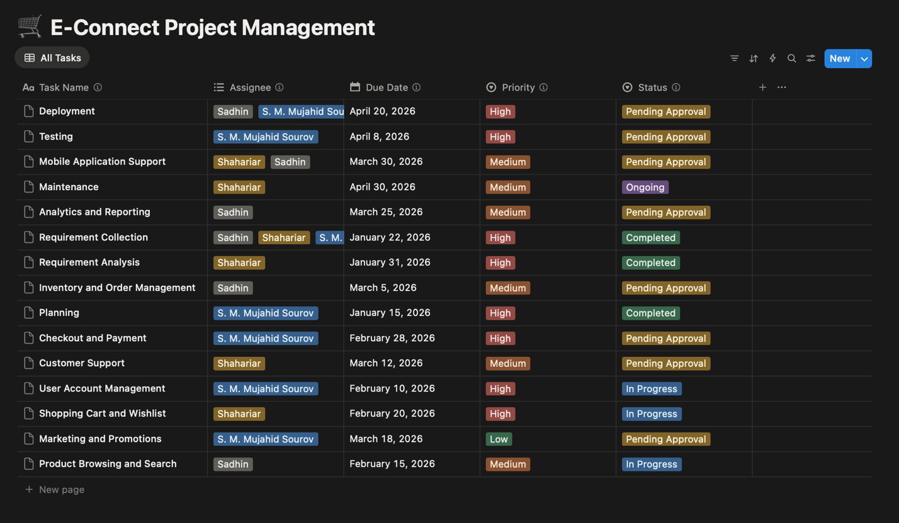
Fig: Table

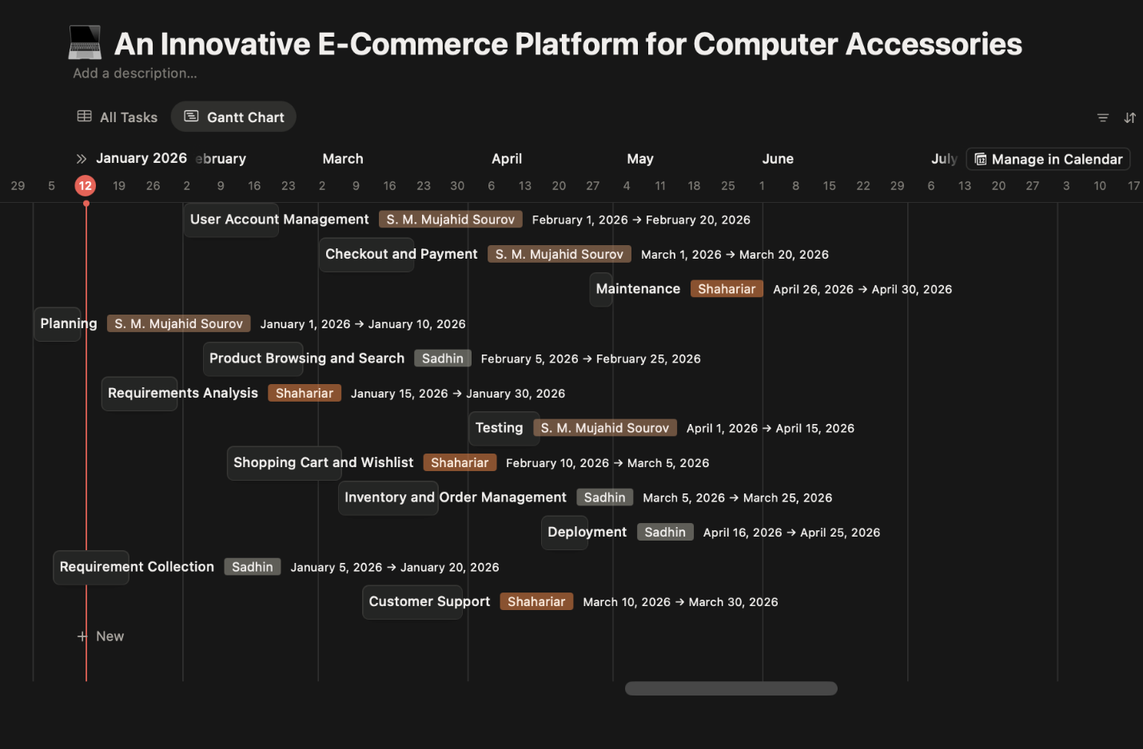
Fig: Gant Chart

Development Plan with Project Schedule

6.1 Planning Phase
  - Objective: Define the project's scope, identify stakeholders, estimate costs, and outline the schedule.
  - Key Activities:
    - Conduct market research to identify competitors and user needs.
    - Define features like product customization, user account management, and secure payments.
    - Prepare a feasibility report and business case.
    - Assign roles to team members and finalize the project plan.
  - Deliverables:
    - Project charter.
    - High-level timeline and budget.
    - Risk assessment report.

Requirements Analysis Phase
  - Objective: Gather and document the functional and non-functional requirements.
  - Key Activities:
    - Collect requirements from stakeholders (e.g., admins, customers).
    - Document user stories for all features: account management, product browsing, and checkout.
    - Define technical requirements for security, scalability, and integration with payment gateways.
    - Develop a Software Requirements Specification (SRS).
  - Deliverables:
    - SRS document.
    - Use case diagrams and workflows.
    - Feature prioritization list.

6.3 Design Phase
  - Objective: Create the blueprint for the system architecture and user interface.
  - Key Activities:
    - Design the database schema for inventory, orders, and user profiles.
    - Develop wireframes and prototypes for web and mobile interfaces.
    - Plan the API architecture for backend communication.
    - Identify and finalize technologies (e.g., React for frontend, Node.js for backend).
  - Deliverables:
    - Database schema.
    - System architecture diagrams.
    - UI/UX prototypes.

6.4 Implementation Phase
  - Objective: Build the system modules and integrate them into a working platform.
  - Key Activities:
    - Develop core modules:
      - User Account Management: Registration, login, password recovery.
      - Product Browsing and Search: Filtered search, categorized listings.
      - Shopping Cart: Add, remove, and save items.
      - Checkout and Payment: Secure payment gateway integration.
    - Develop the admin panel for inventory management.
    - Implement the mobile application with push notifications.
  - Deliverables:
    - Fully developed web platform and mobile application.
    - Backend services and APIs.

Testing Phase
  - Objective: Ensure the system works as intended and meets all requirements.
  - Key Activities:
    - Perform unit testing for individual modules.
    - Conduct integration testing for seamless module communication.
    - Run user acceptance testing (UAT) with beta users.
    - Conduct performance and security testing for high reliability.
  - Deliverables:
    - Bug reports and fixes.
    - UAT sign-off document.

6.6 Deployment Phase
  - Objective: Launch the system to a live environment.
  - Key Activities:
    - Set up the production environment and database.
    - Perform a final quality check before going live.
    - Launch the platform and announce it through marketing campaigns.
  - Deliverables:
    - Live web and mobile applications.
    - Deployment documentation.

6.7 Maintenance Phase
  - Objective: Continuously improve and maintain the system post-launch.
  - Key Activities:
    - Monitor system performance and user feedback.
    - Roll out updates and feature enhancements.
    - Provide customer support through live chat and ticketing systems.
  - Deliverables:
    - Performance reports.
    - Updated features and resolved bugs.

Marketing Plan
This marketing plan aims to promote the computer accessories e-shop to tech enthusiasts, professionals, gamers, and casual users. The main goal is to raise brand awareness, gather leads, convert prospects into customers, and keep current customers satisfied. The plan includes short- term, long-term, and ongoing strategies to ensure the lasting growth and success of the business.

7.1 Short-Term Marketing Plan (0-6 Months)
- Brand Awareness & Visibility
  - Goal: Establish an online presence and generate initial traffic to the website.
  - Tactics:
    - Launch social media campaigns on platforms like Instagram, Facebook, Twitter, and LinkedIn with visually appealing content, including product teasers, promotions, and giveaways.
    - Run targeted paid advertising on Google and social media platforms to reach tech enthusiasts, gamers, and professionals looking for computer accessories.
    - Collaborate with micro-influencers and tech bloggers for product reviews, unboxing videos, and shout-outs.
    - Offer discounts or free shipping on the first purchase to incentivize new customers.
- Product Launch and Promotions
  - Goal: Introduce your product catalog to the market and attract early buyers.
  - Tactics:
    - Host an online launch event or promotion with exclusive deals and discounts.
    - Provide limited time offers on popular products like keyboards, mice, and gaming headsets to encourage first-time purchases.
    - Implement a referral program to encourage customers to share the e-shop with others in exchange for discounts.
- Email Marketing & Lead Generation
  - Goal: Collect email addresses and build a database of potential customers.
  - Tactics:
    - Offer a sign-up discount or exclusive content in exchange for email subscriptions.
    - Use automated email campaigns to welcome new subscribers and nurture leads with product recommendations and special offers.

7.2 Long-Term Marketing Plan (6 Months - 2 Years)
- Content Marketing & SEO
  - Goal: Establish your e-shop as a trusted source for computer accessories and improve organic traffic.
  - Tactics:
    - Start a blog focused on product reviews, tech tips, buying guides, and news related to computer accessories.
    - Optimize website content for SEO to rank for relevant keywords like “best gaming mouse,” “wireless keyboard for PC,” and “high-quality laptop accessories.”
    - Guest post on tech blogs or collaborate with industry websites to expand your reach.
- Partnerships & Collaborations
  - Goal: Build credibility and extend your reach to new audiences.
  - Tactics:
    - Partner with gaming influencers, tech YouTubers, and review sites to promote your products and provide honest feedback.
    - Explore partnerships with popular online tech forums, computer hardware retailers, or gaming events.
    - Offer bundle deals with popular tech products like laptops or PCs to attract new customers.
- Customer Reviews & Testimonials
  - Goal: Build trust with potential buyers through authentic feedback.
  - Tactics:
    - Encourage customers to leave reviews and testimonials after purchases.
    - Highlight positive reviews on the website and social media to build social proof.
    - Offer incentives such as discounts on future purchases for customers who leave reviews.

7.3 Ongoing Marketing Plan (Continuous)
- Customer Retention & Loyalty Programs
  - Goal: Keep current customers engaged and encourage repeat purchases.
  - Tactics:
    - Launch a loyalty program where customers earn points for each purchase, which can be redeemed for discounts or exclusive products.
    - Regularly update the catalog with new arrivals and exclusive products to keep customers coming back.
    - Send personalized email campaigns with product recommendations, promotions, and early access to new arrivals based on customer browsing or purchase history.
- Social Media Engagement
  - Goal: Build an active, engaged community around your brand.
  - Tactics:
    - Post daily or weekly content showcasing new arrivals, customer reviews, and helpful product tips.
    - Run interactive campaigns, polls, and contests to engage followers on platforms like Instagram and Twitter.
    - Use video content to demonstrate product features, offer tutorials, and showcase customer stories.
- Email Marketing & Updates
  - Goal: Maintain regular contact with customers and keep them informed.
  - Tactics:
    - Send monthly newsletters with updates on new products, upcoming sales, and customer success stories.
    - Continue nurturing leads who have abandoned their carts or have not made a purchase in a while with targeted email campaigns.
- Referral & Affiliate Programs
  - Goal: Expand customer base through word-of-mouth and affiliate partnerships.
  - Tactics:
    - Offer a referral program where customers can refer friends and family in exchange for discounts or rewards.
    - Develop an affiliate marketing program where bloggers, YouTubers, and influencers can earn a commission for referring customers to the e-shop.

Cost and Profit Analysis

Development Costs (One-Time)

Cost Item | Estimated Cost (BDT) | Notes
Domain & Hosting (1 Year) | 15,000 - 25,000 | Business plan hosting + SSL
Website Design & Development | 150,000 - 300,000 | Custom MERN Stack or CMS customization
Payment Gateway Setup | 10,000 - 15,000 | SSLCommerz / Shurjopay integration fees
Trade License & Legal | 15,000 - 25,000 | Trade license, TIN, BIN setup
Office/Warehouse Setup | 50,000 - 100,000 | Shelving, basic furniture, packaging station
Initial Inventory (Stock) | 500,000 - 800,000 | Keyboards, Mice, Headsets (High demand items)
Marketing Assets | 20,000 - 30,000 | Logo, branding, initial photography
Total Startup Capital | 760,000 - 1,295,000 | Required investment to launch

Operational Costs (Ongoing)
Cost Item | Monthly Cost (BDT) | Notes
Warehouse/Office Rent | 20,000 - 35,000 | Small space in a non-prime location
Customer Support Executive | 15,000 - 20,000 | Entry-level salary (1 person)
Digital Marketing Budget | 30,000 - 50,000 | Facebook Ads, Google Ads boosting
Logistics & Packaging | 100 - 150 (Per Order) | Variable cost (Cartons, bubble wrap, tape)
Utilities & Internet | 5,000 - 8,000 | Electricity, Broadband
Miscellaneous | 5,000 | Maintenance, unexpected costs
Total Fixed Monthly Cost | ~80,000 BDT | Excluding variable product/shipping costs

8.3 Revenue Projections
- Average Order Value (AOV): 4,500 BDT (Mix of high-end and budget accessories)
- Cost of Goods Sold (COGS): 3,150 BDT (Assuming 70% cost / 30% Gross Margin)
- Packaging & Gateway Fees: 150 BDT
- Gross Profit Per Order: 1,200 BDT
Projected Sales Volume
- Target: 3 orders per day (Month 1) growing to 10 orders per day (Month 6).
- Month 1 Sales: 90 Orders × 4,500 BDT = 405,000 BDT Revenue
- Month 6 Sales: 300 Orders × 4,500 BDT = 1,350,000 BDT Revenue
Break-Even Point (Units) = Total Fixed Monthly Costs / Gross Profit Per Unit
Break-Even Point = 80,000 BDT / 1,200 BDT = 66.67 (Approx. 67 Orders/Month)
We needs to sell approximately 2.2 products per day to cover operational costs (Rent, Salary, Internet). Any sale beyond the 67th order is pure Net Profit.

Projected Profit
Description | Amount (BDT) | Calculation
Total Annual Revenue | 10,800,000 | Avg 200 orders/month × 4,500 BDT
Less: Cost of Goods Sold (70%) | -7,560,000 | Product sourcing costs
Gross Profit | 3,240,000 | 30% Margin
Less: Operating Expenses | -960,000 | 80,000 Fixed Cost × 12 months
Less: Variable Marketing | -600,000 | Ad spend (scaled with growth)
Net Profit (Before Tax) | 1,680,000 | ~15.5% Net Margin

Investor Consideration
Investors are likely to be interested in the scalability and long-term growth
- Scalability: This business can grow quickly with increased marketing efforts and a larger customer base.
- Market Potential: The computer accessories market is a billion-dollar industry with consistent demand.
- Profitability: Once initial expenses are covered, the business can become profitable as customer retention improves and marketing costs become more efficient.

Risk Mitigation Strategy We have established a clear financial roadmap to manage early-stage risks. By monitoring the Marketing Cost per Acquisition (CPA) and maintaining a low break-even point (67 orders/month), the business can recover from initial startup losses and transition into profitability efficiently.

References
- bKash. Payment Gateway Integration for Online Businesses.
Available at: https://www.bkash.com/
- SSLCommerz API Documentation (for Payment Gateway integration). [Online]. Available: https://developer.sslcommerz.com/

- Shopify. How to Develop an E-commerce Website: The Ultimate Guide.
Available at: https://www.shopify.com/

- Notion Labs Inc. Notion Project Management Documentation.
Available at: https://www.notion.so/

- Unified Modeling Language (UML) Diagrams. https://www.geeksforgeeks.org/system-design/unified-modeling-language-uml-introduction/

- Break Even Point. https://corporatefinanceinstitute.com/resources/accounting/break-even-analysis/

